**Aryaman Mishra**

**19BCE1027**

**Experiment 2**

Aim: Implement caeser cipher encryption technique for a **text file** or audio file.

**Code:**

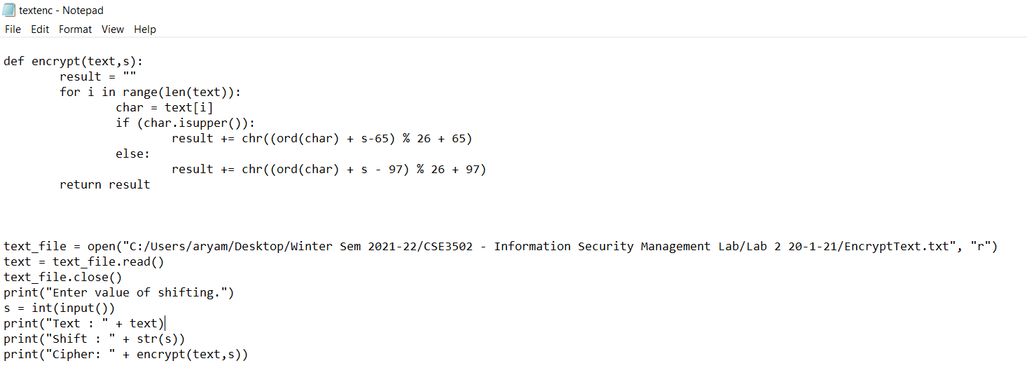

def encrypt(text,s):

result = ""

for i in range(len(text)):

char = text[i]

if (char.isupper()):

result += chr((ord(char) + s-65) % 26 + 65)

else:

result += chr((ord(char) + s - 97) % 26 + 97)

return result

text_file = open("C:/Users/aryam/Desktop/Winter Sem 2021-22/CSE3502 - Information Security Management Lab/Lab 2 20-1-21/EncryptText.txt", "r")

text = text_file.read()

text_file.close()

print("Enter value of shifting.")

s = int(input())

print("Text : " + text)

print("Shift : " + str(s))

print("Cipher: " + encrypt(text,s))

**Output:**

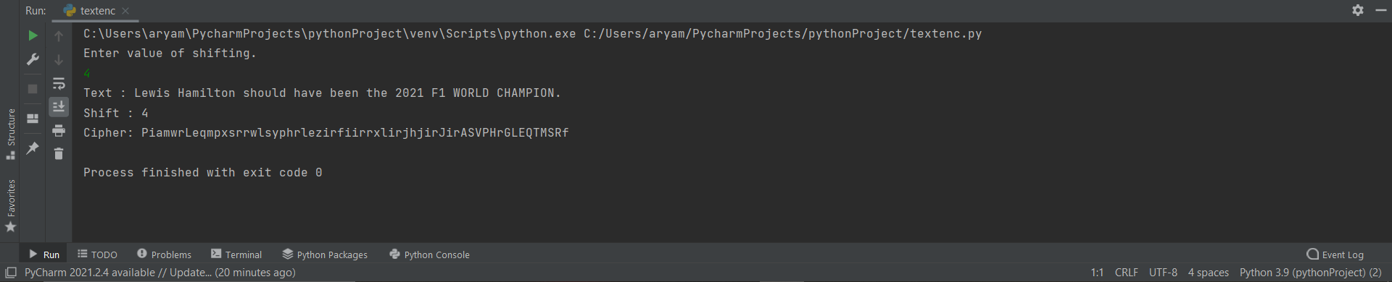

**Conclusion:**

Cipher for Text file has been successfully implemented for a text file and output for text file containing “Lewis Hamilton should have been the 2021 WORLD CHAMPION” is denoted in output screenshot.